Task-Based Activity: Review a wedding checklist
Laubach Connection: Laubach Way to Reading (LWR) Book 3, Lesson 5
OALCF Link
Relevant Goal Paths
Apprenticeship, Employment, Independence, Postsecondary, Secondary School Credit
Rationale: Learners on all of the goal paths will need to use lists for a variety of different reasons.

Task-Based Activity Description: The learner will interpret a simple document (wedding checklist) to locate specific details. The learner will make simple calculations using time to determine the correct month.
Competency, Task Group and Level Indicators
(See Assessment page for performance descriptors)
A: Find and Use Information
A2: Interpret documents
- A2.2 Interpret simple documents to locate and connect information

C. Understand and Use Numbers
C2: Manage time
- C2.1 Measure time and make simple comparisons and calculations

Materials Required
- Pen or pencil and eraser
- Question sheets

Overview
Activity Introduction
This task uses a wedding checklist.

In lesson five, Jason and Gail get married. Discuss with the learner if they are married or have ever been part of a wedding. Discuss the importance of using checklists when planning events or activities to make sure you don’t miss anything. Ask the learner if they use lists.

New words
Determine any new words that you think are being introduced in the activity and review those words with the learner.

Instructions
- Have the learner fill in their name and the date.
- Have the learner complete the pre self-assessment.
- Have the learner complete the task-based activity.
- After completing the activity, have the learner complete the post self-assessment.
- After the learner has completed the task-based activity, complete the assessment section and review the results with the learner.

Extension activities

- Create a variety of different to-do lists
- Use an online program to create a to-do list (e.g. OneNote)

Task-Based Activity: Review a wedding checklist

Learner Name: _____________________________ Date: ____________________________

Pre self-assessment

I need to improve my skills at using lists:
- Yes
- No

Activity
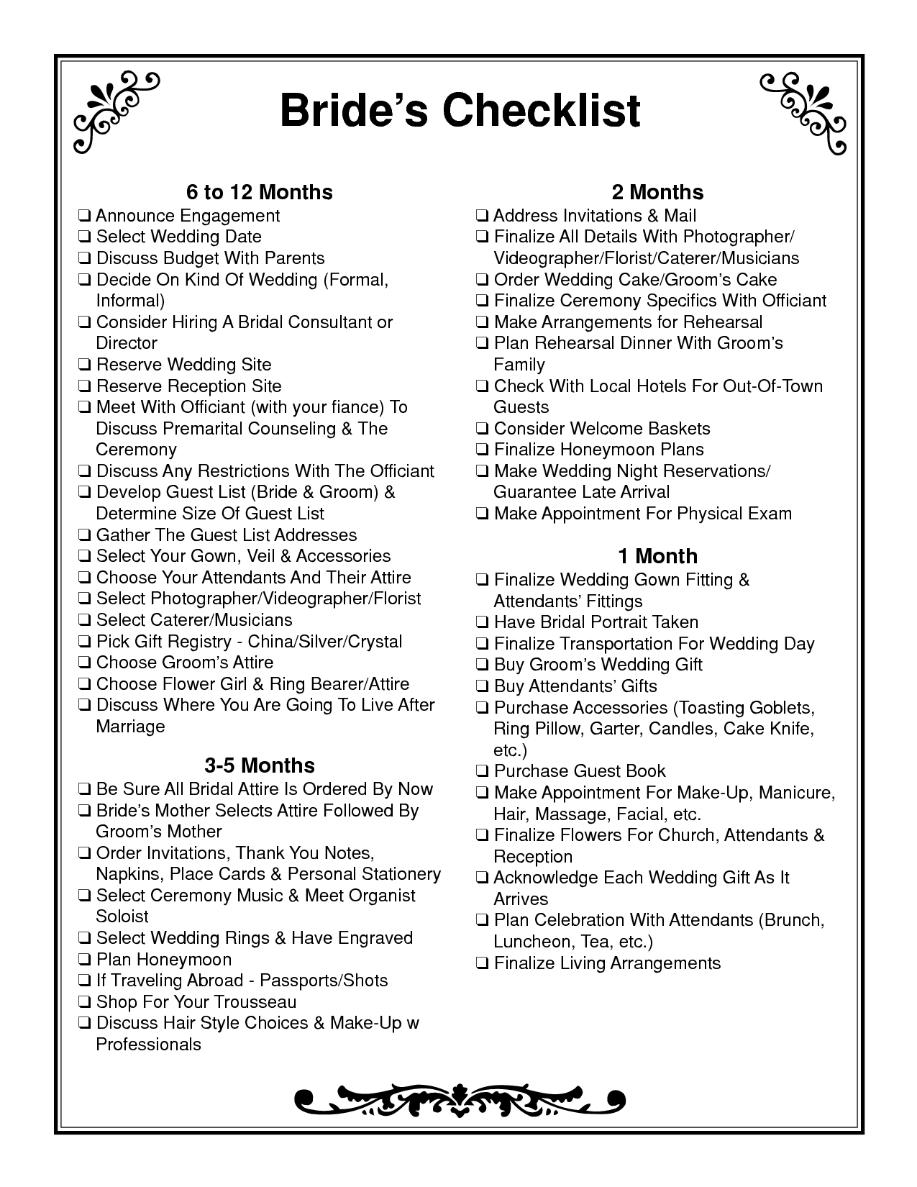
- When should you select a wedding date? ____________________________________

- If you are getting married in July, what month should you address and mail your wedding invitations? ________________________________________

- When is the best time to select a photographer for your wedding? ________________

_______________________________________________________________________

- What should you do if you are planning to go on a honeymoon abroad? ___________

_______________________________________________________________________

- What do you think are the three most important things to do 3-5 months before your wedding?

- __________________________________________________________________

- __________________________________________________________________

- __________________________________________________________________

- This checklist is for a bride. Is there anything missing from the list that a groom might need to do? ________________________________________________________________________

________________________________________________________________________

________________________________________________________________________

Post self-assessment

I think my skills have improved as a result of completing this activity.
- Yes
- No

Learner comments:
______________________________________________________________________________
______________________________________________________________________________
______________________________________________________________________________

Assessment
Task-Based Activity: Review a wedding checklist
Learner Name: _____________________________ Date: ____________________________

Practitioner Name: _______________________________________

Performance Descriptors | Needs Work | Improving | Excellent
A2.2: Interpret simple documents to locate and connect information
- performs limited searches using one or two search criteria
- extracts information from tables and forms
- locates information in simple graphs and maps
- uses layout to locate information
- makes connections between parts of documents
- makes low-level inferences
- begins to identify sources and evaluate information

C2.1: Measure time and make simple calculations
- adds, subtracts, multiplies and divides whole numbers and decimals
- recognizes values in number and word format
- understands chronological order
- understands and uses common date formats
- identifies and performs required operation
The learner needs to work on the following:

This task was successfully completed ______ This task needs to be tried again ______

Practitioner Comments:

Learner Comments:

